Report

# Task1 1

$openssl req -x509 -newkey rsa:2048 -keyout alice.priv -out alice.pub -days 100 -nodes

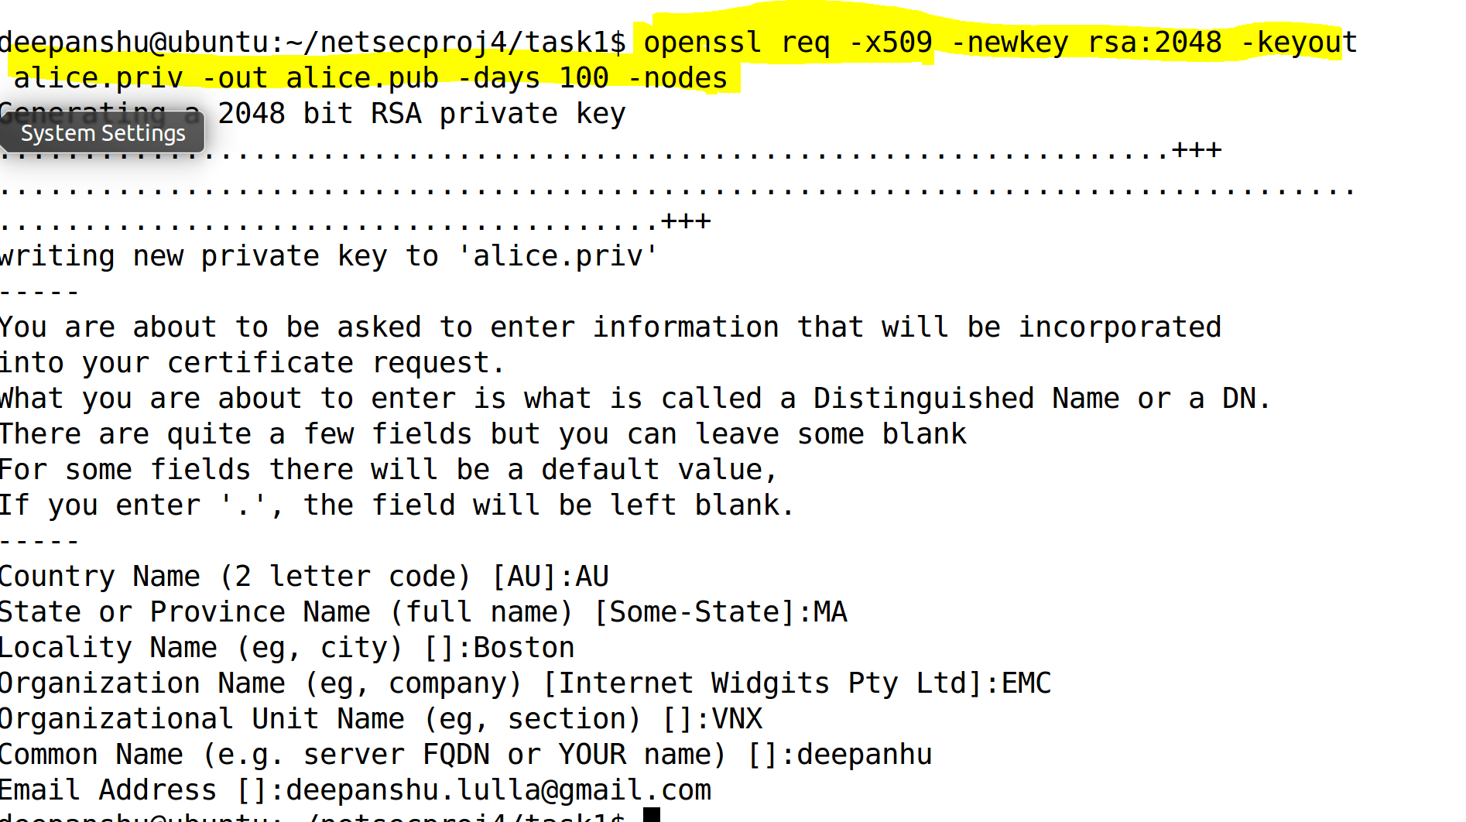

# Task 2

The first step involved generation of public and private keys.

$openssl genrsa -out alice.priv 2048 && openssl rsa -in alice.priv -outform PEM -pubout -out alice.pub

$openssl genrsa -out bob.priv 2048 && openssl rsa –in bob.priv -outform PEM -pubout -out bob.pub

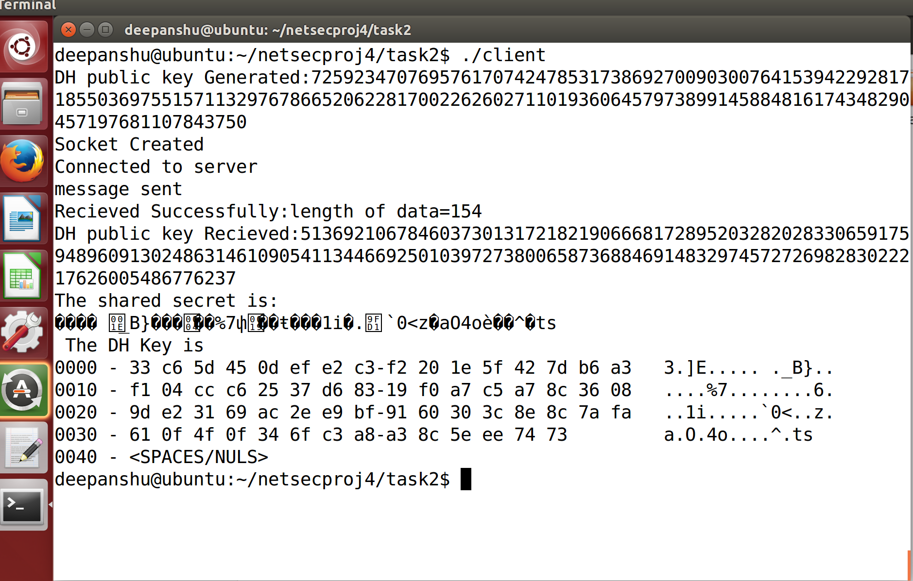

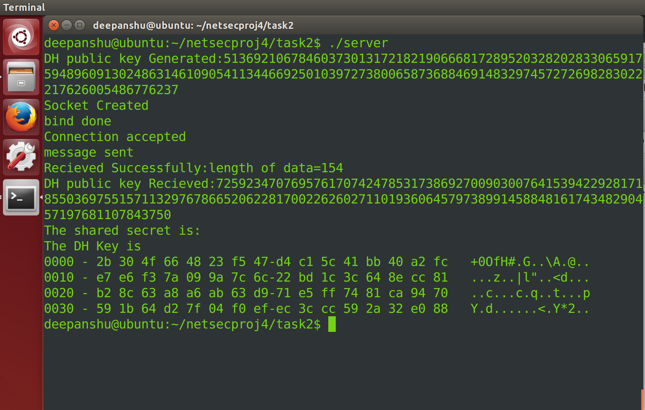

# Task 3

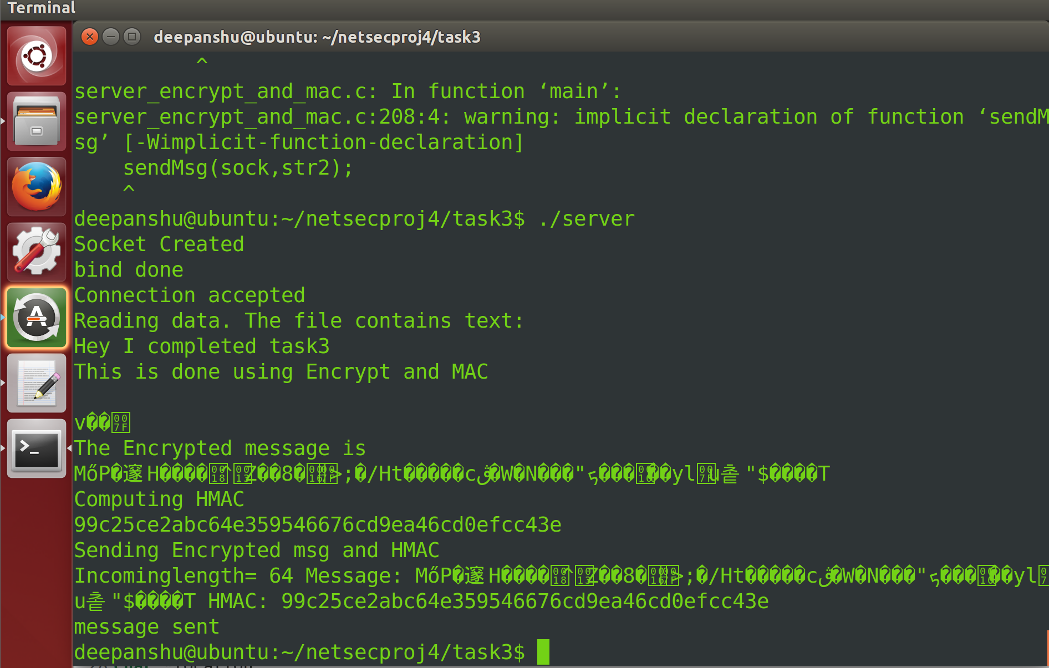

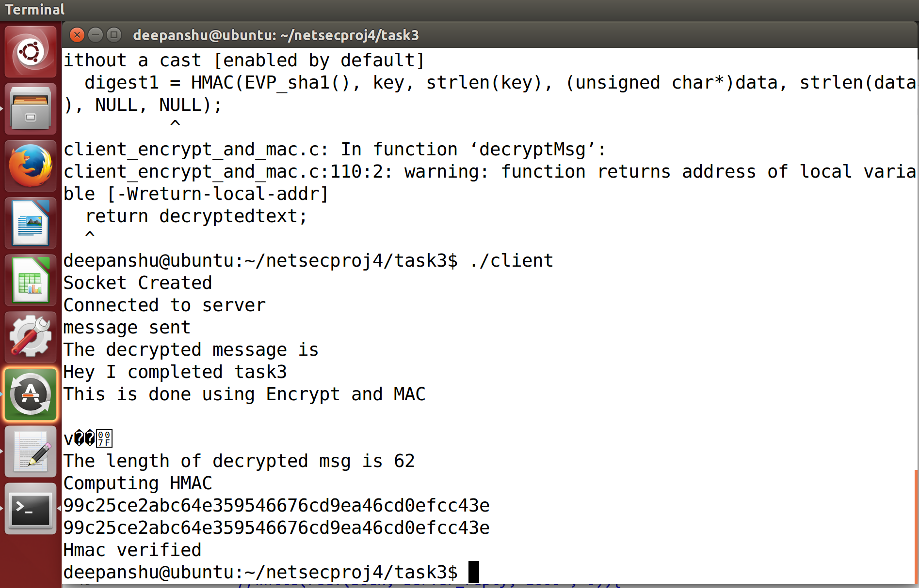

# Task 4

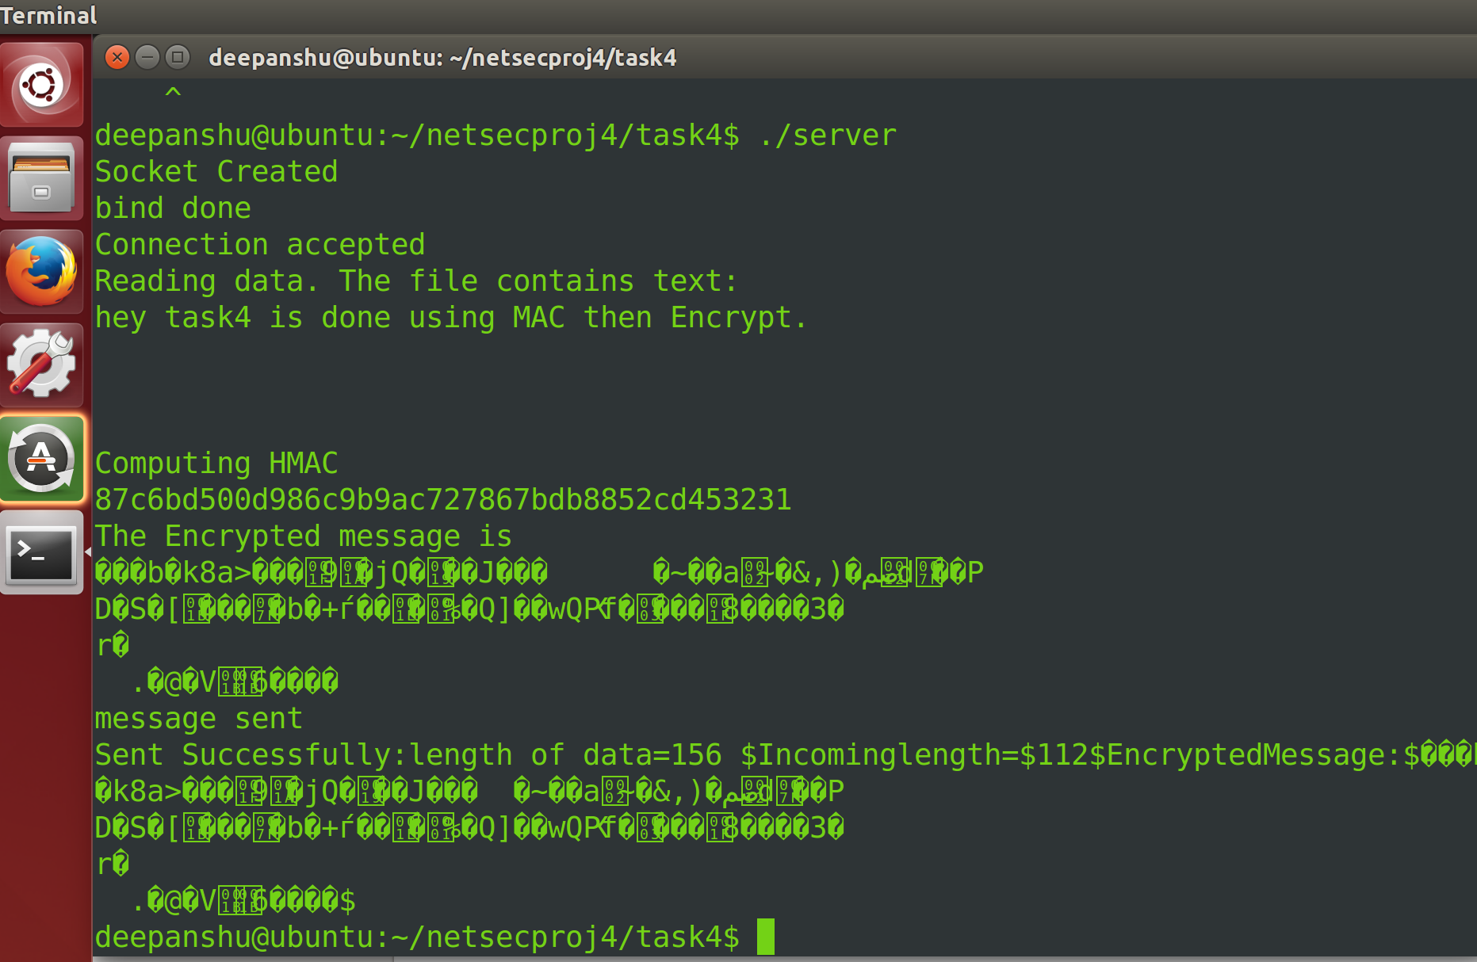

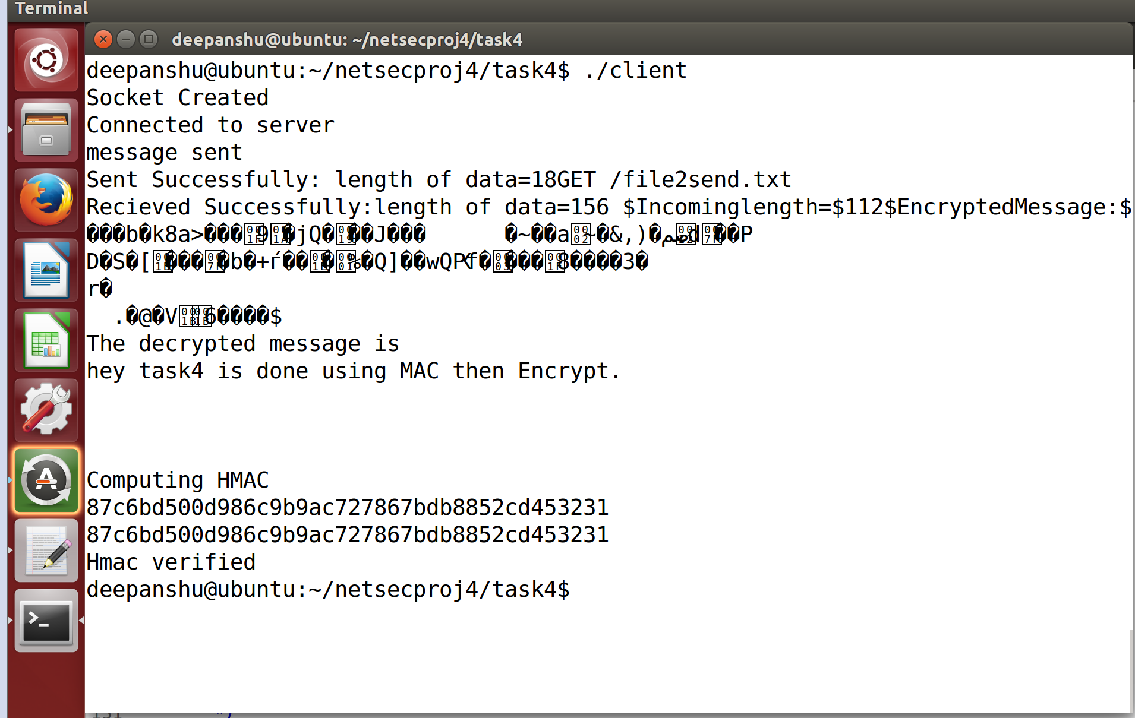

# Task 5

